Telephone: 01466 792627 Fax: 01466 794962

39 Gordon Street, Huntly, Aberdeenshire AB54 8EQ

VETERINARY SURGEONS
STRATHBOGIE VETERINARY CENTRE LTD

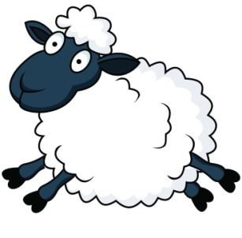It’s coming round to that time of year again – busy days, sleepless nights, and lack of social life(?!) .... yes lambing and calving time is approaching!
Firstly sheep. The weeks prior to lambing starting is when we see most abortions occurring. There are many causes of abortion – both infectious; Enzootic abortion (chlamydophila), toxoplasma, campylobacter, listeria and salmonella being the main culprits and non infectious; stress, poor nutrition, pregnancy toxaemia and chronic conditions such as fluke and pneumonia. There will always be the odd ewe which aborts, and records should be kept of these ewes. If you have more than 3 or 4 in 100 ewes abort over a few days then further investigations should be undertaken to determine the cause of the abortion. Please get in touch with us to discuss cases and start investigations. This would involve samples/carcases taken to the SAC lab in Aberdeen – ideally; all aborted material; placenta and foetus or if this cannot be done then we can take samples from the placenta/carcase and send to the lab for culture and investigation. Further to investigation we can then discuss further treatments/precautions to put into place to minimise further losses. After abortion has occurred it is important to; remove all material and clean the area/bedding and isolate the ewe.
Enzootic Abortion of Ewes (EAE) is the most commonly seen cause of infectious abortion (around 55%) It is caused by a bacteria – chlamydophila abortus. Abortion usually occurs in the last 3 weeks of pregnancy, and ewes appear otherwise healthy, possibly with a discharge, and lambs are freshly dead or alive (but weak). Transmission is mainly via coming into contact with aborted material, vaginal discharges or infected live born lambs. The outcome of infection is very much dependant on when the ewes were infected – if they were infected in the first half of pregnancy, then abortion will occur in the last 3 weeks of pregnancy. If the ewes were infected in late pregnancy/when not pregnant, then the abortion will occur in the final 3 weeks of the next pregnancy – ie not until the next year in some cases. If a lamb survives and goes on to be pregnant, she will abort during her first pregnancy. Diagnosis is confirmed with a stain at the lab, but having a good look at the placenta can indicate EAE; necrosis/discolouration of cotyledons and yellow/pink pus areas. Controlling EAE requires good biosecurity and hygiene plus injecting the flock with oxytetracycline (alamycin LA) – however this should ideally only be used in the face of an outbreak. It would be advised that ewes which have aborted should not be used again for breeding or surviving ewe lambs. Vaccination of all breeding sheep should be done at least 4 weeks prior to tupping and then vaccinating replacements the following years.
Toxoplasma is responsible for around 25% of infectious abortion. It is caused by a protozoan parasite which is ingested by the ewe. It is present in cat faeces which contaminate feed and is ingested by the ewe. Ewes again appear clinically normal after aborting. Outcome is again dependant on the time of infection occurring; early pregnancy – causing embryonic death/reabsorption – this may be seen as an increased number of barren ewes at scanning time. Infection during mid pregnancy causes foetal death, mummies and foetal growth is reduced. Late pregnancy infection would be seen as freshly dead lambs or live weak lambs which fail to thrive. A diagnosis again is reached at the lab – by histology, the placenta can appear with small white areas present and the foetus also displays changes seen on a full post mortem. Control involves the use of; sulphonamide drugs or decoquinate in the last 14 weeks of pregnancy. However vaccination is the best way to control toxoplasma – a single dose administered at least 3 weeks before tupping and should last at least 2 years.
Please bear in mind that many of these infectious causes of abortion are zoonotic – transmissible to humans, so pregnant women should avoid contact with sheep.
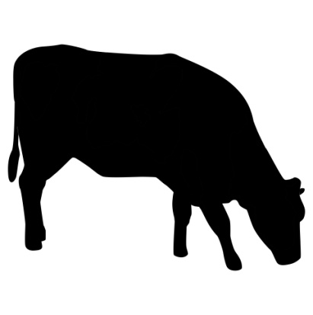Ewes on the Heptavac P programme should also be given their booster injections at least 4-6 weeks prior to lambing to ensure that the lambs receive adequate anti bodies against the clostridial disease covered. Remember though, it is important that the lambs receive adequate colostrum in the early hours of life (50ml/kg in the first 4-6 hours) to ensure they are protected. If you would like to order vaccine then please pop in past or phone to place an order, we usually have stock in the fridge.
If you have had issues with calves scouring in the past then now is the time to think about vaccinating for some of the main causes of scour; ecoli, coronavirus and rotavirus. If calves are covered for these, then they should in theory be stronger and less susceptible to other infections causing scours. There are 2 vaccines available – Rotavec Corona and Bovigen Scour. Both cows and heifers regardless of previous vaccination status can be given a 3ml injection into the muscle of Bovigen Scour in the 12-3 week period before calving is suspected.This allows adequate antibody levels to be present in the colostrum however it is essential that calves receive AT LEAST 3 litres of colostrum in the first 24 hours of life or approx 10% of the calves bodyweight for the antibodies to be absorbed. If you would like to order or discuss the vaccines further then please give us a ring.
Colostrum – its all about quality AND quantity and you certainly get what you pay for! Adequate colostrum intake in the first 6 hours of life is essential to allow antibodies to be absorbed through the gut. This provides the calf with ‘passive immunity’ against diseases which they are susceptible to especially in the first few weeks of life whilst their immune systems are establishing. If you are unsure a calf has sucked it is best to stomach tube it to be on the safe side. Ideally milk the cow as she will have antibodies to diseases on the farm – although there will always be that one who doesn’t oblige! There are a variety of colostrums available on the market – some designed to be used as a top up colostrum, and some to be used when no natural colostrum has been consumed. Please make sure that the colostrum you purchase is certified as Johnes, IBR and EBL free – as these can be passed via milk to the calf. A spare bag of colostrum never goes a miss, feel free to ask about the ones we stock.
Finally, we would like to introduce Sarah McLaughlin who has joined us as a part time receptionist.

Back by popular demand... a few jokes for you...
After announcing he's getting married, a boy tells his pal he'll be
wearing the kilt.
'And what's the tartan?' asks his mate.
'Oh, she'll be wearing a white dress,'
Wee Billy: Whats a ‘caesarian section’?
Dad: The Caesarian section is a district in Rome.

