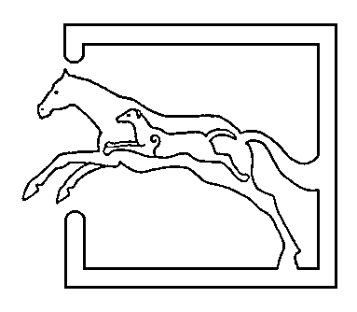
39 Gordon Street, Huntly, Aberdeenshire AB54 8EQ

Telephone: 01466 792627 Fax: 01466 794962

VETERINARY SURGEONS
STRATHBOGIE VETERINARY CENTRE LTD

Spring has fairly sprung over the past few weeks and it is nice to see lambs and calves going about. There are a few things that young lambs and calves are particularly susceptible too in their first few weeks of life – unfortunately getting them on the ground can only be the start of whats to come!
Firstly colostrum – it’s something that we talk about a lot but it really is essential in giving youngsters the best start to life and can prevent many diseases taking hold. It is recommended that they receive 10% of their bodyweight (in litres) in the first 24 hours of life – a calf should have at least 3 litres in the first 4-6 hours. If in doubt, tube feed to ensure they receive adequate colostrum. Lambs should have 50ml/kg in the first 4-6 hours of life and about 200ml/kg in the first 24 hours.
Its been said many a time that a sheeps aim in life is to die! However there are many ways we can try to increase neonatal survival. Hygiene is a good place to start – ensuring lambing pens are clean, dry (powders are available), well bedded and disinfected regularly, ideally between lambings though in reality this is difficult to achieve! Clean pens are not only beneficial for the newly born lambs but also ewes, decreasing chances of spread of other contagious conditions such as mastitis and foot issues. The use of prophylactic antibiotics as soon after birth as possible (Spectam or Orojet) can also reduce the incidence of scours and watery mouth. Dipping navels with strong iodine or blue spray is essential in reducing navel ill and joint ill. Signs of navel ill/joint ill are redness, swelling, temperature, lameness, being tucked up, and not rising. Good first line antibiotics to use are; betamox (rpt in 2days) or noroclav/synulox (daily injection) and a painkiller/anti-inflammatory as well. If this doesn’t resolve the infection then please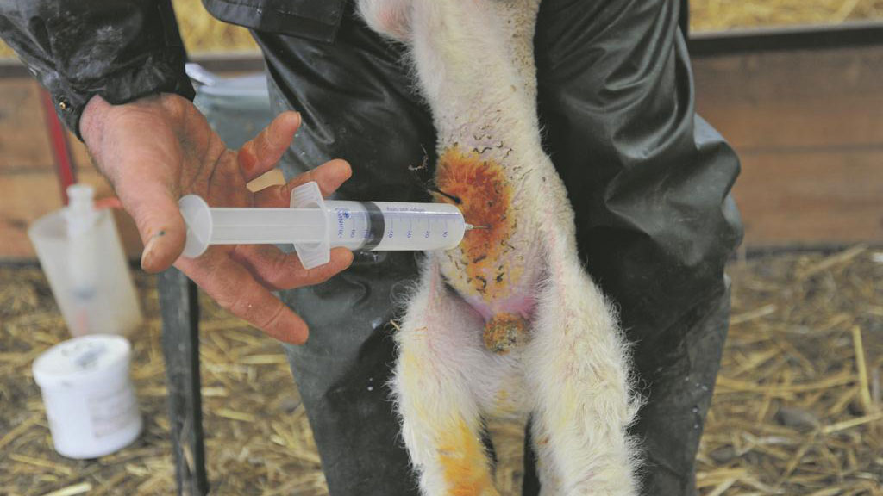 come in and see us. We see a few lambs every year born with no anus, causing them to become bloated and discomfort. If you notice a lamb with this condition, then we can try to fix the problem, however it may not always be successful due to the rectum not being present but worth a try. With the weather we have had recently keep an eye on lambs both inside and outside which become hypothermic. Lambs should be warmed, given colostrum and monitored closely. An intraperitoneal injection of warmed glucose can be given in severely hypothermic cases – 20% glucose at a rate of 10ml/kg. The injection is given using a 1 inch, 19G needle inserted below and to the side of the navel and directed towards the tail head. (see the picture above)
https://www.fginsight.com/vip/vip/handy-hints-top-10-tips-to-help-keep-lambs-alive-170414-774
Another condition we commonly see at this time of year is scours – both in lambs and calves. There are many causes of scours; both infectious/protozoal/parasitic and non – infectious. If you are having scour issues then it may be worth bringing us a sample – we can run a test in house for calves or send a sample away to the lab for analysis. Scouring calves can go downhill very quickly, and can become very flat and dehydrated fast. Keeping calves dehydrated can be difficult and they can require dripping with fluids and bicarbonate (as many become acidotic). However, regular tubing with fluids containing; effydryl (cannot be mixed with milk), rehydion (can be mixed with milk) is essential to trying to maintain hydration. The viruses – rota and coronavirus cause severe damage to the intestine lining – basically removing the absorptive capacity of the intestines and making them much more susceptible to other disease. Vaccinating cows/heifers during the last 3-12 weeks of pregnancy with Bovigen Scour/Rotavec Corona provides the calves with antibodies in the colostrum to protect the calves. It is essential that the calves receive adequate colostrum for this to be effective!
Cryptosporidium is a parasite which invades the intestines, and oocysts are shed in faeces which can survive in bedding, water, feed etc. Treatment/ prevention of cryptosporidium is good hygiene and also halofuginone (7 day oral treatment and accurate dosing is required) and keeping the calves hydrated. Crypto can affect us as well – especially the young and old and I am told it is not a pleasant experience!! Other causes of scour can be; salmonella, ecoli, campylobacter, coccidiosis (usually 3 week to 3 month old lambs and calves).

A quick update about BVD - the Scottish Government have changed the rules regarding check tests. From April 1st if the number of calves per management group exceeds 50, then we will need to blood sample more calves from the group (10%). A management group is defined as..’ Within a breeding herd, any bovine animals, that for a period of two months or more, graze or are housed together (a) separately from other animals in the herd; and (b) in sufficient proximity to each other to allow BVDV to circulate amongst them.’
If you are buying animals from the following sources, these animals are classed as ‘risky’ and will need to be blood sampled to test for BVD;
- Calves born on Scottish non-breeding holdings that have not been individually tested for BVD.
- Cattle moving off a Scottish “not negative” herd that do not have an individual negative status (either BVD test result or assumed negative from having a calf)
- Cattle without individual BVD test results coming from herds outside Scotland.
THESE ANIMALS WILL NEED TO BE TESTED OTHERWISE YOU WILL LOSE YOUR NEGATIVE HERD STATUS
A few really baaaad jokes for lambing time...
Why do cows like being told jokes?
Because they like being amoosed!
What did the baby corn say to the mama corn?
Wheres popcorn?
Whats the best part of farming?
Getting down and dirty with my hoes!
Who tells chicken jokes?
Comedihens

