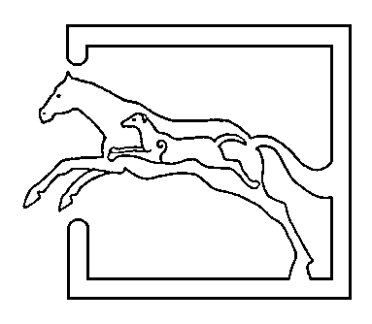
39 Gordon Street, Huntly, Aberdeenshire AB54 8EQ

Telephone: 01466 792627 Fax: 01466 794962

VETERINARY SURGEONS
STRATHBOGIE VETERINARY CENTRE LTD

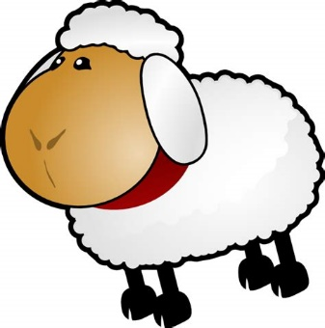The tup sales are starting, and the lads should hopefully be looking in good condition before they are turned out with the ewes again. Have a good check over of the tups – now is a good time (10 weeks prior to tupping) to check the tups are in good health. Generally check; body condition (should be 3.5-4 before tupping starts), teeth, feet for lameness, and no obvious respiratory or gastrointestinal disease is present. Some conditions are very infectious and contagious so have a look for any signs of these – footrot ,CODD, CAE (caseous lymphadenitis – swollen glands). Have a feel of his testicles – checking for any asymmetry, lumps, bumps and any painful areas. For piece of mind we can do a semen test on the tups – to check sperm numbers, motility and also morphology. We are offering a Ram MOT – which includes a full clinical examination and semen test at an introductory price! Please call for more information or to book a visit.
Just a quick reminder that toxovax and enzovax vaccinations should be done a month before tups are put in with the ewes. These cover two of the main causes of abortion – toxoplasma and enzootic abortion (EAE). If you are vaccinating ewes/replacements then please ring and speak to Michelle to place your order for vaccine.
With the nights starting to draw in again, it will soon be time to think about housing cattle again for the winter. So now would be the time to start thinking about vaccinating for the respiratory viruses; IBR (infectious bovine rhinotracheitis), BVDV (Bovine Viral Diarrhoea Virus), PI3 (Parainfluenza virus), RSV (respiratory syncytial virus). There are many different vaccines present on the market – each covering different combinations of the viruses. Pneumonia is costly – both in terms of reduced daily liveweight gains (DLWG), reduced production, increased medicine costs and is labour intensive. Many animals which get over the initial pneumonias are more susceptible to it again, and there can be losses seen. Some vaccines (such as rispoval 4) – an injection – needs 2 doses a few weeks apart. It is best if this is started prior to housing – although I understand there is extra handling of the cattle required. With all diseases – prevention is better than cure, and it is usually the viruses which cause the initial damage in the lungs which allow secondary bacteria to invade and leads to further infection. There are many different vaccine protocols available aimed at different groups of animals. For more information then please feel free to speak to any of us.
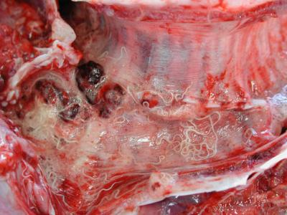We have seen a few cases of lungworm (dictyocaulus viviparus) this summer. Signs to look out for are; coughing, nasal discharge, increased respiratory effort and rate. Cattle do build immunity to lungworm, however do require a parasite challenge to boost their immunity. Naïve cattle – bought in from other areas or first year grazing cattle are particularly at risk. Treatment should be prompt as lungworm infection can predispose to other lung infections. A worming product – containing any class of wormer should be administered and steroids can also be given. Sampling can be done – testing for larvae in the faeces – this would need to be sent to the lab for analysis. (picture from https://www.agriculture.gov.ie/animalhealthwelfare/laboratoryservices/regionalveterinarylaboratoryreports/rvlmonthlyreports2010/october2010rvlmonthlyreport/)
A few things to finish off for this month… We raised £70 for the RSABI from the raffle held at the sheep meeting – many thanks for donations and buying raffle tickets!
We will be closed on Saturday 6th October, for Sarah and Marks Wedding – however Richard Brown will be covering for us so your animals are all in safe hands!! We wish Sarah and Mark all the best for the future as Mr and Mrs Hamilton.

