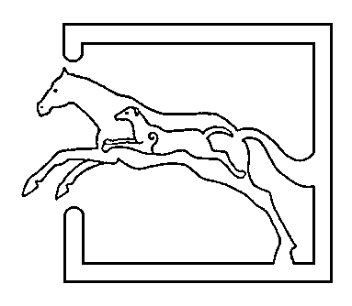
39 Gordon Street, Huntly, Aberdeenshire AB54 8EQ

Telephone: 01466 792627 Fax: 01466 794962

VETERINARY SURGEONS
STRATHBOGIE VETERINARY CENTRE LTD

You’ve picked the one, bring him home but.... is he upto the job? Could he be one of the 20% of tested bulls that are subfertile? An infertile or subfertile bull can be costly and not only due to getting fewer cows/heifers pregnant. Other knock on effects include a protracted calving period – and nobody wants to be getting up through the night longer than they have too! Over the next few months we are offering Bull semen testing at a reduced price of £50 (+VAT) per bull. This includes certification and a written report on the findings of both the physical examination and the microscopic/ morphological examination. We are currently using an electro ejaculator probe to obtain the sample, then counts are done on farm and then more back at the practice. If you would like more information or to book a visit then please phone the office.
Special Offer Bull Semen testing £50 + VAT
Whilst on the topic of semen testing, we were considering buying a ram ejaculator to test tups before going in with the ewes. If this is something you would be interested in then please let us know!
With the summery weather we have had over the past week or so its time to start keeping an eye out for blowfly. Ewes are much more susceptible at this time of year, and lambs slightly later on. There are a variety of pour ons available – some for prevention) and others such as crovect or ectofly lasting 8 weeks and used for both prevention and treatment. As well as causing issues with maggots, flies can also contribute to spread of mastitis. Signs to look out for with mastitis are; swollen, firm hard udder, apparent lameness and also noisy hungry lambs and calves. Treatment with a pain killer/anti-inflammatory and antibiotics are essential as soon as possible.
The suns out, the cattle at grass what could be better? Some breeds of cattle with less pigmentation such as Charolais and Herefords are more susceptible to photosensitisation caused UV light. There are 2 types; primary and secondary. Primary photosensitisation(an allergic reaction to bright light!) occurs when the agent is either; ingested, injected or absorbed. Clinical signs to watch out for are; crusty lesions on the skin – especially the udder, nose, around the eyes and ears. Areas of sunburn – reddening of non pigmented skin, and in some cases peeling of the skin can occur. Administration of steroid and B vitamins is recommended as well as keeping the affected animal(s) inside out of direct sunlight.
Another quick reminder about toxovax..... How many barren ewes is too much? – A common question we are asked. Anymore than 2% of the flock which are barren should be investigated. MSD is offering a free lab test to check for toxoplasmosis and chlamydophila (EAE) - the most common causes of abortion, in 6-8 barren/aborted ewes. To qualify for this test you must not be vaccinating with toxovax/enzovax at present.
On the topic of vaccinating for toxoplasma, if you usually vaccinate then there is a special offer for vaccines ordered and used between the 1st of June and the 31st August , an extra 5 % discount. Breeding females should be vaccinated anytime between 4 months and 3 weeks pre tupping, giving you plenty of time to plan ahead! Remembering that the shelf life of toxovax is short ,so needs doing as soon as you receive it.

